MAKE SKILLED IoT INTERNSHIP

ASSIGNMENT – 6

ARDUINO CONNECTIONS WITH FLEX SENSOR & LED

* + HERE WE WILL BE USING ARDUINO INTERFACE.
  + COMPONENTS REQUIRED:
  1. ARDUINO UNO BOARD
  2. PC / LAPTOP INSTALLED WITH ARDUINO IDE SOFTWARE
  3. LED
  4. FLEX SENSOR
  5. JUMPING WIRES
  + CIRCUIT DIAGRAM

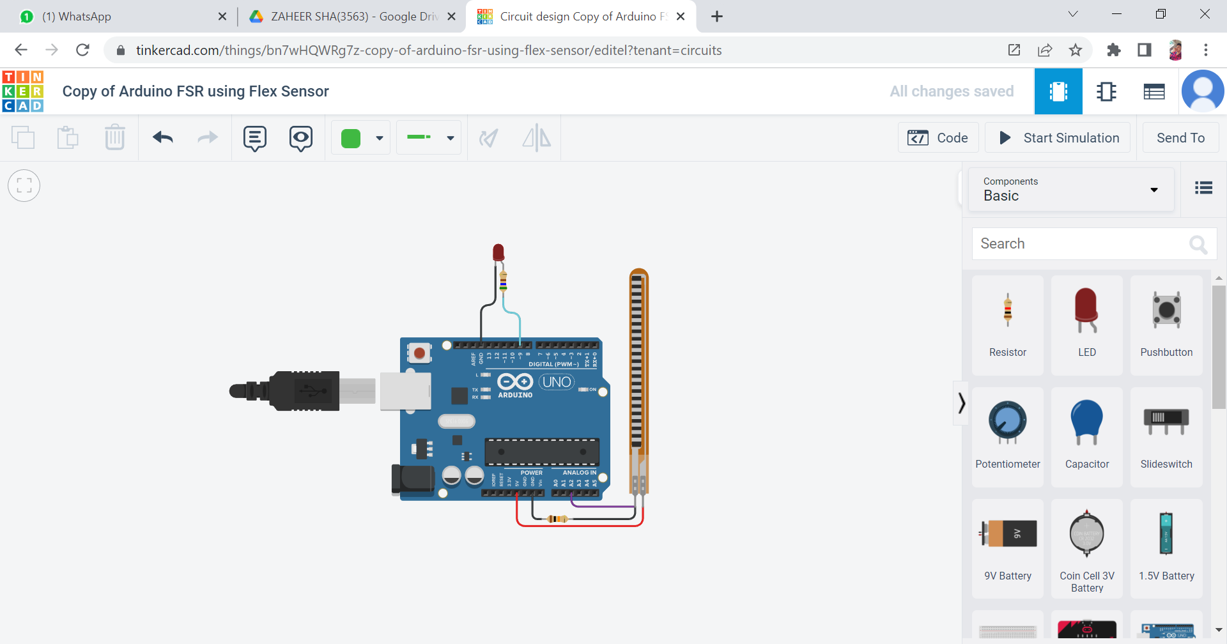

* PROGRAM

const int ledPin = 9;

const int flexPin = A2;

int value;

void setup(){

pinMode(ledPin, OUTPUT);

Serial.begin(9600);

}

void loop(){

value = analogRead(flexPin);

Serial.println(value);

value = map(value, 700, 900, 0, 255);

analogWrite(ledPin, value);

delay(100);

}

**By Team : AKULA ZAHEER SHA , TAUFEEQ BASHA & QUIZER SHAH**